TASK-21 (Outputs)

1. Hello People.

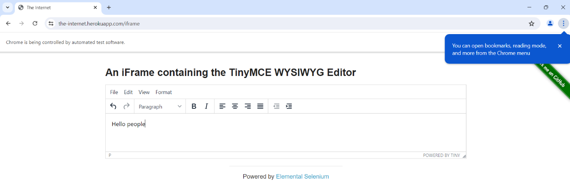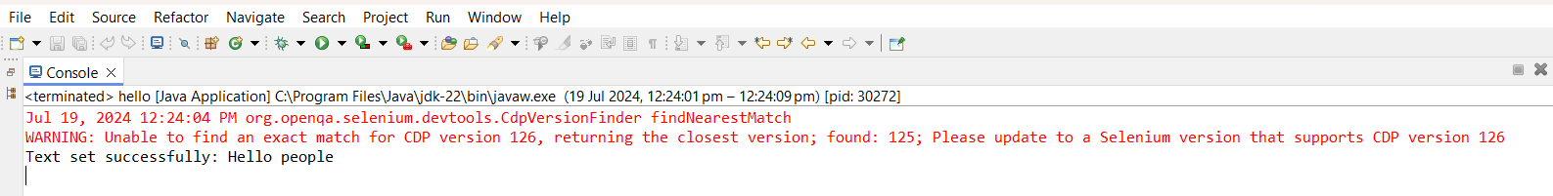

1. New Window.

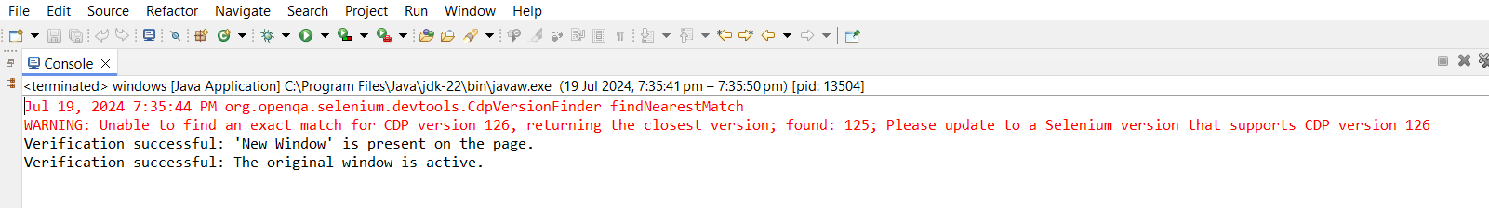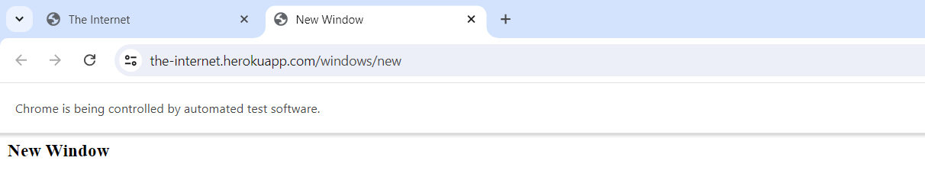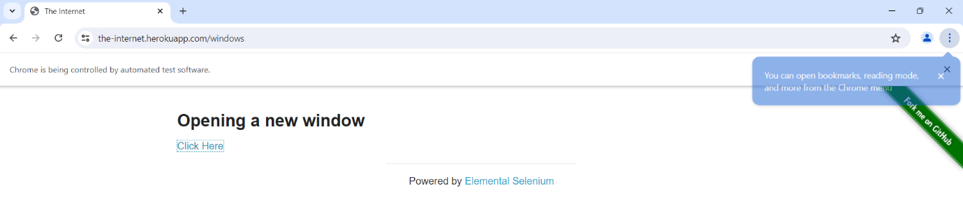

1. Frames.

